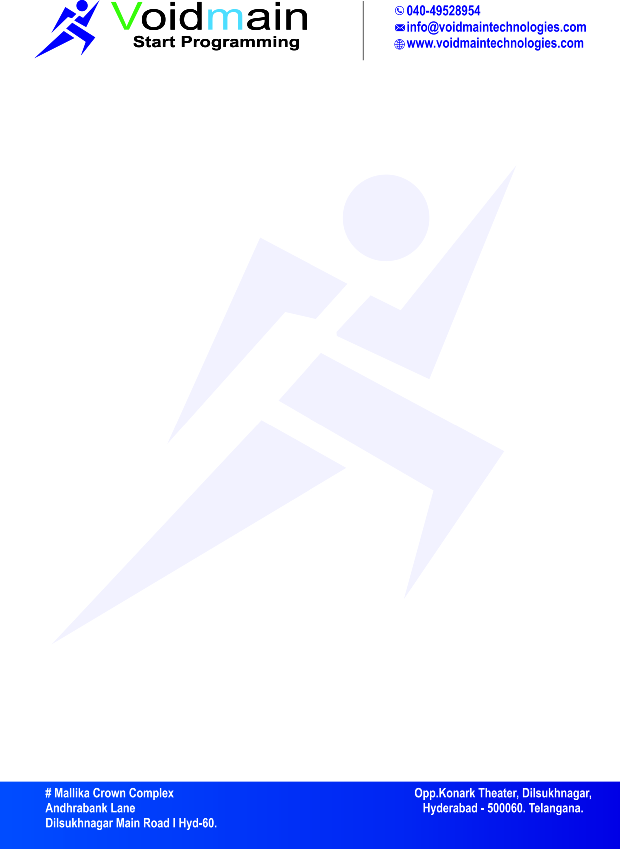

**Date: 12-06-2022**

**CERTIFICATE**

This is to certify that the following students of Bachelor’s Degree (Computer Science and Engineering) at **“Sreyas Institute of Engineering and Technology”**

**B. SRAVANTHI (18VE1A0507)**

**G.NIKITHA (18VE1A0512)**

**G.MOUNIKA (18VE1A0514)**

**V.SREEJA (18VE1A0553)**

They has done their project for 120 days (from 08/02/2022 to 11/06/2022) as an internship at **“VOIDMAINTECHNOLOGIES”** to accomplish their Project **(A study of Blockchain Technology in Farmer’s Portal)** Design, Implementation and Testing. During the period of their internship with us, they was found punctual, hardworking and inquisitive.

We wish them all the best for their future endeavors.

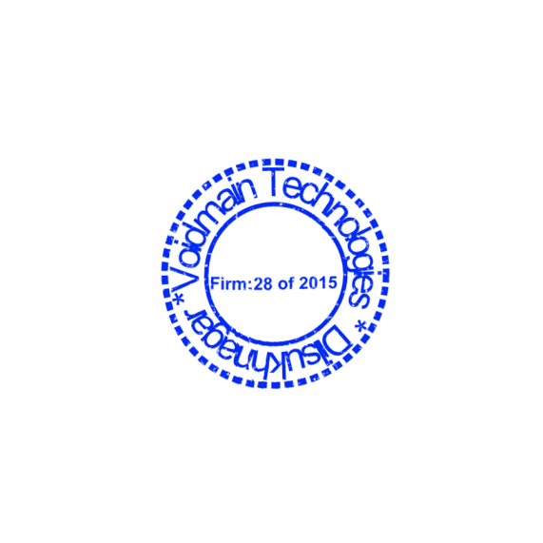

**VOIDMAIN TECHNOLOGIES**

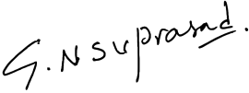**Hyderabad.** **Authorized Signature**